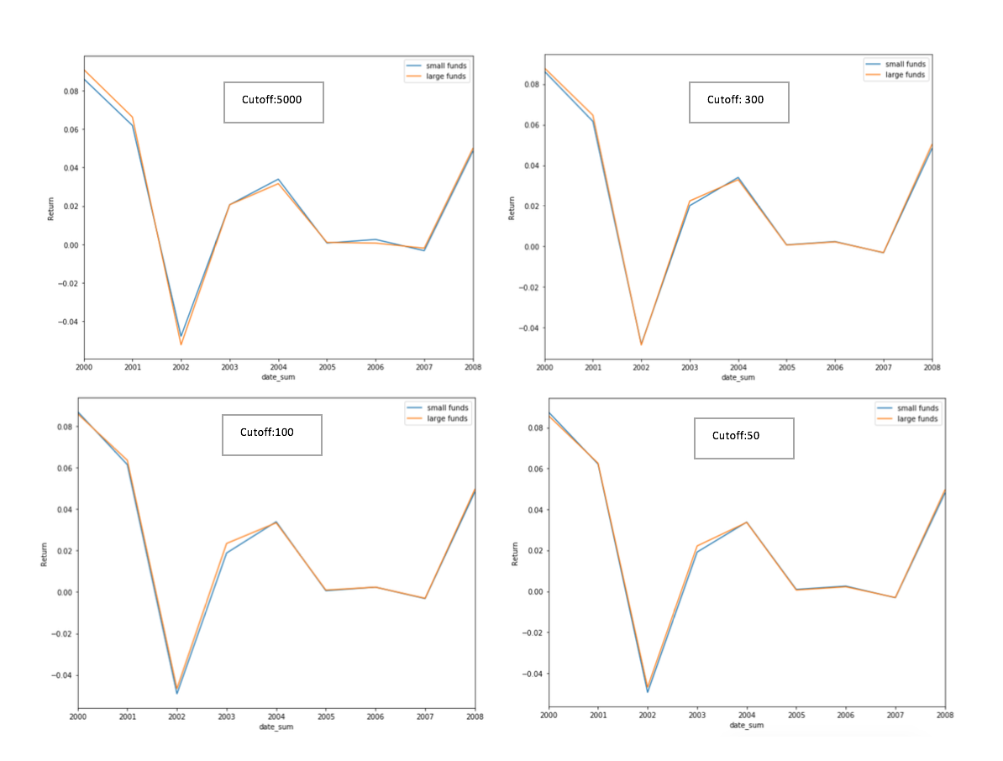**2000 - 2008:**

**Method:** After receiving the data from WRDS, the Lipper codes was used to identify U.S. small-cap mutual fund. Further cleaning was done by assessing the structure of the mutual fund, keeping only the pure-equity mutual funds. The monthly return data was merged with the mutual fund data based on date and CRSP Fund Numbers. For this time period, we set a total NAV cutoff threshold to determine if the funds were small or large. From there, the average return was calculated for both small and large funds and then graphed based on cutoff threshold to determine relative effect of the change in threshold value.

**2008 - 2018:**

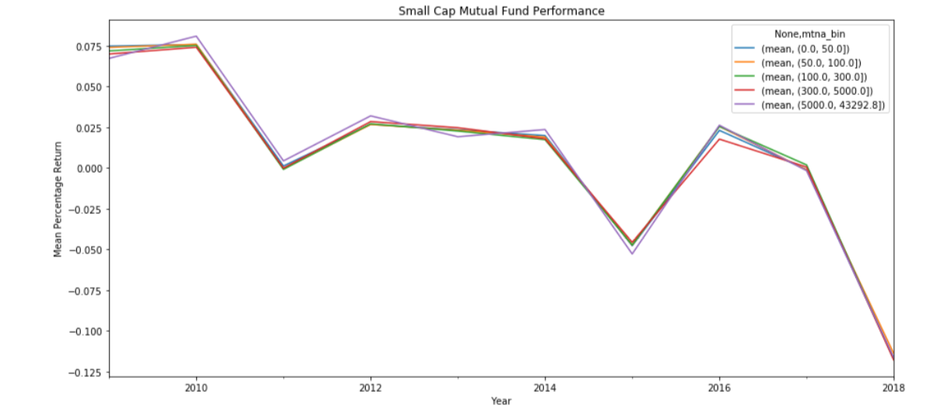

**Method:** We completed the same data processing as mentioned above. For this time period, we completed some exploratory data analysis to determine how to bin the small cap funds by size, and calculated the average monthly returns to determine the value of each mutual fund. While our bin sizes were not all equal, we felt they approximately represented the various fund sizes based on the distribution of the data.

**Conclusion:** For 2000-2008, small funds perform better around the dotcom bubble. Otherwise, the performance varies when cut-off threshold changes. For the year from 2008-2015, the performance of the larger funds on average outperform all other mutual funds sizes. After 2015, it seems smaller funds outperform larger funds. Zooming in on 2015-2018, funds with Total NAV less than 100 outperform larger funds. We can conclude that the performance of mutual funds is dependent not only on fund size, but also on the time period that we are observing.